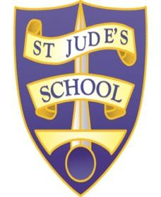
St Jude’s CE Primary School
JOB TITLE: Cover Supervisor
REPORTS TO: Senior Leadership Team
GRADE: Pay band 6
JOB PURPOSE:
To supervise classes in the event of short-term absence usually covering one class consistently for no more than three consecutive days. To manage and supervise pupil behaviour. To contribute to the maintenance of effective school administration.
KEY ACCOUNTABILITIES
To actively promote the School’s Equal Opportunities Policy and observe the standard of conduct which prevents discrimination taking place
To maintain awareness of and commitment to the School’s Equal Opportunity Policies in relation to both employment and service delivery
To fully comply with the Health and Safety at Work Act 1974 etc, the School’s Health and Safety Policy and all locally agreed safe methods of work
At the discretion of the Head Teacher, such other activities as may from time to time be agreed consistent with the nature of the job described above
To work with colleagues to achieve service plan objectives and targets
To participate in Employee Development schemes and Performance Management and contribute to the identification of own team development needs
PRINCIPAL RESPONSIBILITIES/DUTIES
• Supervising work that has been set in accordance with the school policy.
• Support the Curriculum Plan and learning programmes designed by the teacher.
• Responding to any questions from pupils about process and procedures.
• Providing feedback to the classroom teacher on the pupil’s progress against lesson plans, conduct of the lesson. Keeping pupil related records.
• Dealing with any immediate problems or emergencies according to the school’s policies and procedures.
• Collecting any completed work after the lesson and returning it to the appropriate teacher.
• Attend meetings and training sessions as required.
• Provide additional support to teachers in classrooms, to carry out administrative tasks when not covering a class.
• Act as a role model, setting high expectations of conduct and behaviour.
• Report student and school issues in line with the School’s policies for health and safety, child protection, behaviour management etc.
• Be involved in extra curricular activities, e.g. open days, presentation evenings.

