|  |  |
| --- | --- |
| JOB TITLE | Team Leader |
| SERVICE PROVISION | Portsmouth Homeless Drug and Alcohol Team |
| SCALE RANGE | 31-33 |
| CONTRACT TYPE | Fixed term until 31st of March 2026, potentially becoming permanent (to be confirmed) |
| LINE MANAGER | Service Manager |
| DATE OF ISSUE | July 2025 |

**Key Responsibilities:**

* Work closely with and support the Manager in developing the service, including the development and implementation of a variety of interventions across the service. Develop understanding of the changing needs and demands of the client group and lead the team to deliver the service accordingly.
* Support the Manager to develop and implement local policies, procedures and work practices to ensure the effective and safe operation of the service.
* Be responsible for ensuring that staff are carrying out their duties correctly and safely and support the Manager with service user and staff issues as required.
* Hold a small caseload of service users and deliver a range of interventions as required.
* Provide both day-to-day work supervision and formal supervision to staff.
* Ensure that the service is staffed adequately at all times and that rotas are monitored and updated to ensure absent staff are covered where necessary.
* Support existing partnership working arrangements and support the Manager to facilitate the development of new partnerships that support the ongoing development of the Service.
* Ensure that the Society of St James’ (SSJ) policies and procedures are implemented properly and, with the Manager, devise new procedures and work practices where relevant.

**Specific Duties:**

|  |
| --- |
| **Staffing** |
| 1. Participate in recruitment and selection, and provide induction for new staff. 2. Provide day-to-day work supervision and coaching to staff, monitor performance and work output and take appropriate action to address performance issues in partnership with the Manager and the HR Department. 3. Actively involve staff and volunteers with decisions about changes to services and encourage them to innovate and think creatively to improve the quality of the services delivered. 4. Contribute to the ongoing development of the staff team through the provision of teaching sessions and workshops. 5. Provide individual supervision and appraisals to all those under direct line management and identify their training and development needs. 6. Identify issues and keep clear records relating to performance and attendance, liaising with HR and your Line Manager and participating in disciplinary investigations and formal sickness and capability meetings when required. |

|  |
| --- |
| Service Users |
| 1. Work closely with the Manager and referring agencies to ensure that the service has a fair and transparent admissions criteria and assessment process to achieve a balance between the provision of safe and manageable environments, and the need to take risks to support individuals faced with complex needs and/or that display behaviours that challenge. 2. Take responsibility for overseeing safeguarding of service users, staff and the wider community. Balance risk assessment and management with safe and effective service delivery. 3. Facilitate service user involvement as required. 4. Monitor the quality of recovery planning to assess staff ability, and ensure that the needs of service users are being appropriately identified and addressed. 5. Issue warnings, and ensure that complaints and appeals are dealt with according to SSJ’s policies. |

|  |
| --- |
| Finance |
| 1. Prioritise in order to ensure that spending decisions are appropriate and money is not wasted. 2. Monitor the budget for the service and, with the Manager, set budgets and review forecasts. 3. Authorise expenditure, including petty cash, timesheets and process expenses claims for authorisation by the Manager in accordance with SSJ’s procedures, paying particular attention to the provision of service user welfare, staff travel and relief staff cover. |

|  |
| --- |
| Administration |
| 1. Work closely with the Manager to provide evidence that the team is delivering the service outcomes and performance targets required. 2. Ensure all files, records, rotas, diaries and personnel records in particular, are accurate and up-to-date. 3. Ensure that all data is managed in accordance with SSJ’s Data Protection Policy and any partnership protocols. 4. Work with the Manager to devise and write new policies, procedures, forms and work practices. |
| Health & Safety |
| 1. Ensure the timely reporting of repairs and maintenance requirements. 2. Support the staff team to respond and manage incidents involving service users, staff and external parties appropriately and safely. 3. Ensure that all safeguarding policies and procedures are implemented and that staff understand their responsibilities in relation to safeguarding service users. 4. Ensure that service user welfare and safety is monitored as required by the Service Manager and Commissioners. 5. Undertake regular health and safety checks and inspections as directed by the Service Manager and delegate specific tasks to individual members of the staff team. 6. Support the Service Manager to ensure that SSJ’s Health & Safety System is implemented correctly throughout the service. |

|  |
| --- |
| **Additional Requirements:** |
| 1. Vary the hours worked to meet the needs of the Service and SSJ, including some evenings, weekends and bank holidays. 2. Deputise for the Manager and other Team Leaders in their absence. 3. With your Line Manager, identify training needs and take responsibility for attending training courses as directed and giving feedback as required. 4. Attend all weekly management meetings and, in the absence of the Manager, attend the bi-monthly Manager’s meetings at head office to ensure that the Service is kept up to date with internal and other external developments. 5. Attend, prepare for and participate in regular supervision, working groups and meetings. 6. Proactively pursue good relationships with neighbours and the local community. 7. Undertake any other duties that might reasonably fall within the post's responsibilities as directed. |

|  |  |
| --- | --- |
| **Experience, Knowledge and Ability – the successful candidate must demonstrate the following:** | **Assessment** |
| Minimum 2 years’ experience working in services providing support to people presenting with problematic alcohol and substance use, mental ill-health and behaviours that challenge | CV |
| Experience of managing staff, including dealing with performance issues | CV INTERVIEW |
| Experience of partnership working and liaison with statutory and voluntary agencies | CV |
| Understanding of the diverse needs of service users with problematic substance use and mental ill-health, and knowledge of harm minimisation and treatment options | CV INTERVIEW |
| Understanding of modern psycho-social interventions, including ACT, mindfulness, CBT and concepts such as recovery capital and harm reduction | CV INTERVIEW |
| Understanding of Equality and Diversity, in relation to both employment of staff and access to services by clients | INTERVIEW |
| Understanding of confidentiality and data protection | INTERVIEW |
| Ability to act on your own initiative and make difficult management decisions under pressure and manage difficult situations | CV INTERVIEW |
| Understanding of risk assessments and risk management | CV INTERVIEW |
| Good standard of listening, verbal and written communication skills to enable effective communication with staff, service users and external agencies | CV INTERVIEW |
| Literacy skills sufficient to write reports and procedures, and numeracy skills sufficient to understand budgets | CV INTERVIEW |
| The ability to organise and manage your time and workload, meeting deadlines and prioritising jobs effectively | CV INTERVIEW |

**The SSJ Competency Framework**

SSJ uses a Competency Framework as part of its recruitment procedures. The SSJ Competency Framework identifies specific competencies that staff in each job role are required to demonstrate. As well as being able to demonstrate the experience, knowledge and abilities required for the role, all staff are required to demonstrate competencies that contribute to each area identified in the Framework Model below:

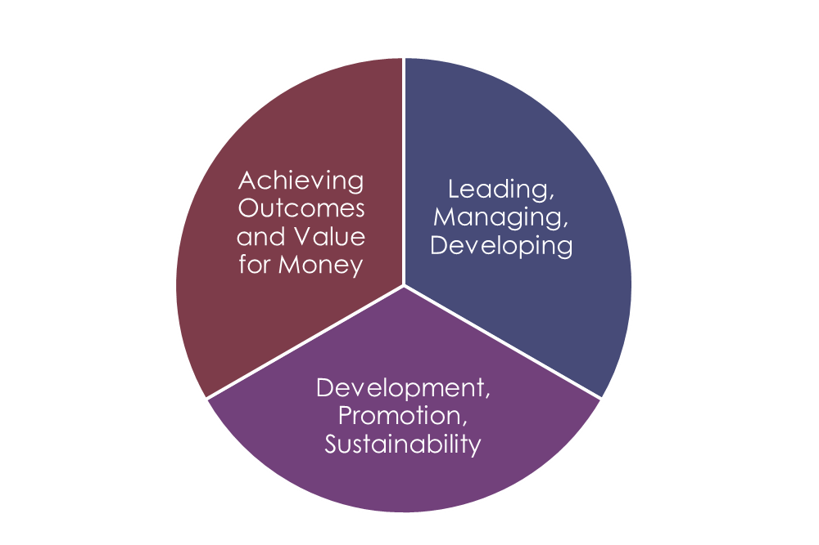

**Purpose:**

The Society of St James (SSJ) requires Managers and Senior Managers to meet the competencies set out below. The Competency Framework is used in the recruitment process and candidates will be expected to complete their CV using the framework to ensure they provide relevant information and examples that demonstrate how they meet the requirements.

It is also used as an ongoing monitoring tool in supervision, appraisal and performance management and should be used by individuals as part of their own self-reflection on their work performance to help identify training needs and areas for development and improvement.

|  |
| --- |
| The Society of St James Management Competency Framework |
| People: Leading, Managing and Developing **Managers must:**   1. Set a positive example through own behaviour and work practice. 2. Motivate staff through active participation in service delivery and development. 3. Build trusting relationships with staff, clients and stakeholders by showing respect and fairness towards them. 4. Encourage staff to find their own solutions to problems and support them to implement them. 5. Enable staff to develop and learn by promoting a learning environment for all. 6. Offer positive and constructive feedback on team and individual performance. |
| **Organisation: Development, Promotion and Sustainability**  **Managers must:**   1. Consistently demonstrate commitment to the organisation’s values and ethos. 2. Encourage staff to engage positively with development opportunities. 3. Promote the organisation to all stakeholders through positive words and actions. 4. Promote a working environment for all based on honesty, fairness and trust. 5. Manage budgets and service development within given guidelines. 6. Assess and manage all risks associated with the service under management and ensure the appropriate response is implemented. |
| **Delivering Results: Achieving Outcomes and Value for Money**  **Managers must:**   1. Be outward looking and able to use initiative to ensure that services achieve required outcomes. 2. Be able to solve problems and use innovative approaches to achieve outcomes. 3. Have a clear vision and strategy for the team to enable them to achieve desired outcomes. 4. Ensure that all financial decisions are considered in the context of value for money. 5. Be able to identify and articulate to others the value for money provided by the organisation. 6. Have the necessary skills to ensure that services adapts to an ever-changing economic environment. |
| **Key Behaviours for Managers at All Levels:**   * Be open and approachable. * Be honest and fair. * Be willing to listen to and to share ideas. * Be a team player. * Be decisive and accountable for the decision made. * Be diplomatic. * Find constructive ways to deal with conflict. * Be a critical friend. * Consistently demonstrate a commitment to the values and ethos of the organisation. |